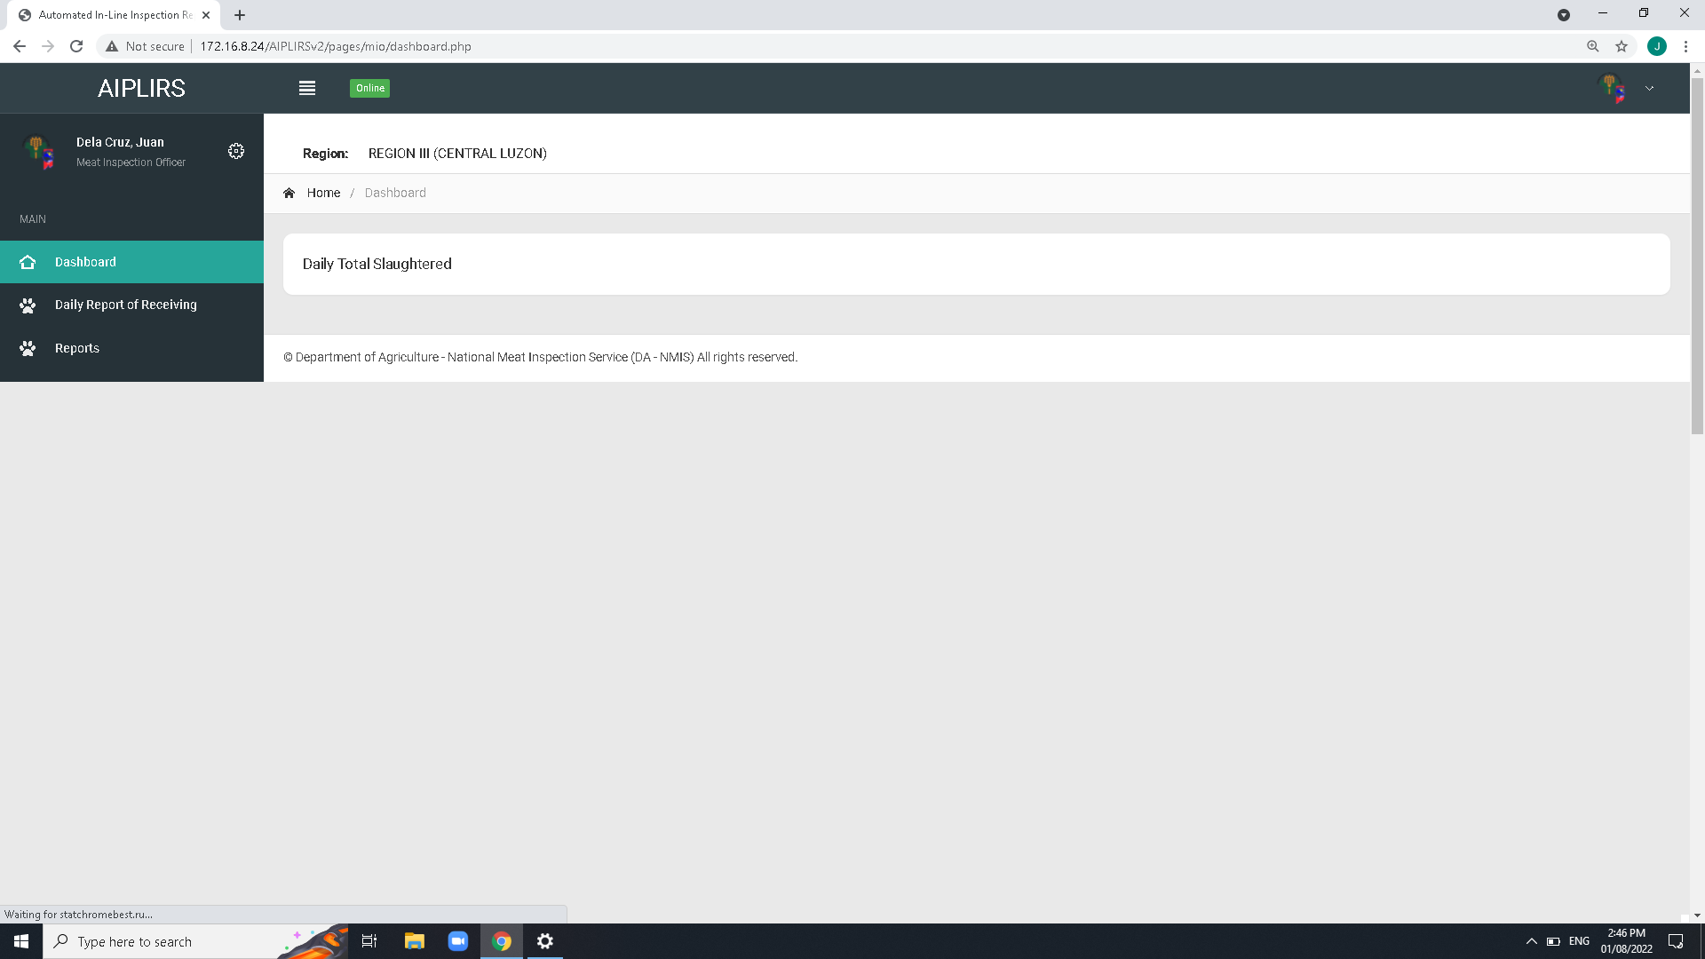

Remove Navigation bar header and breadcrumbs on all pages

Create a summary card for the receiving, fit for slaughter, fit for human consumption

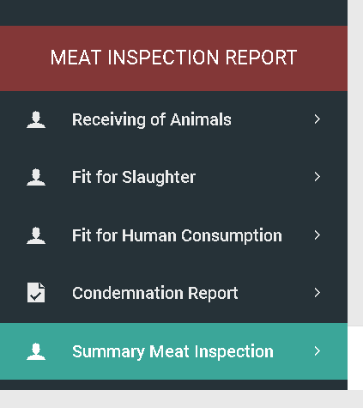

To be added on MIO account sidebar:

Output is the summary on the all Meat establishment assignment base on dates

(suggestions: tick boxes for the Current, previous)

Change header title

Establishment to Meat establishment

Total weight to total weight(kg)

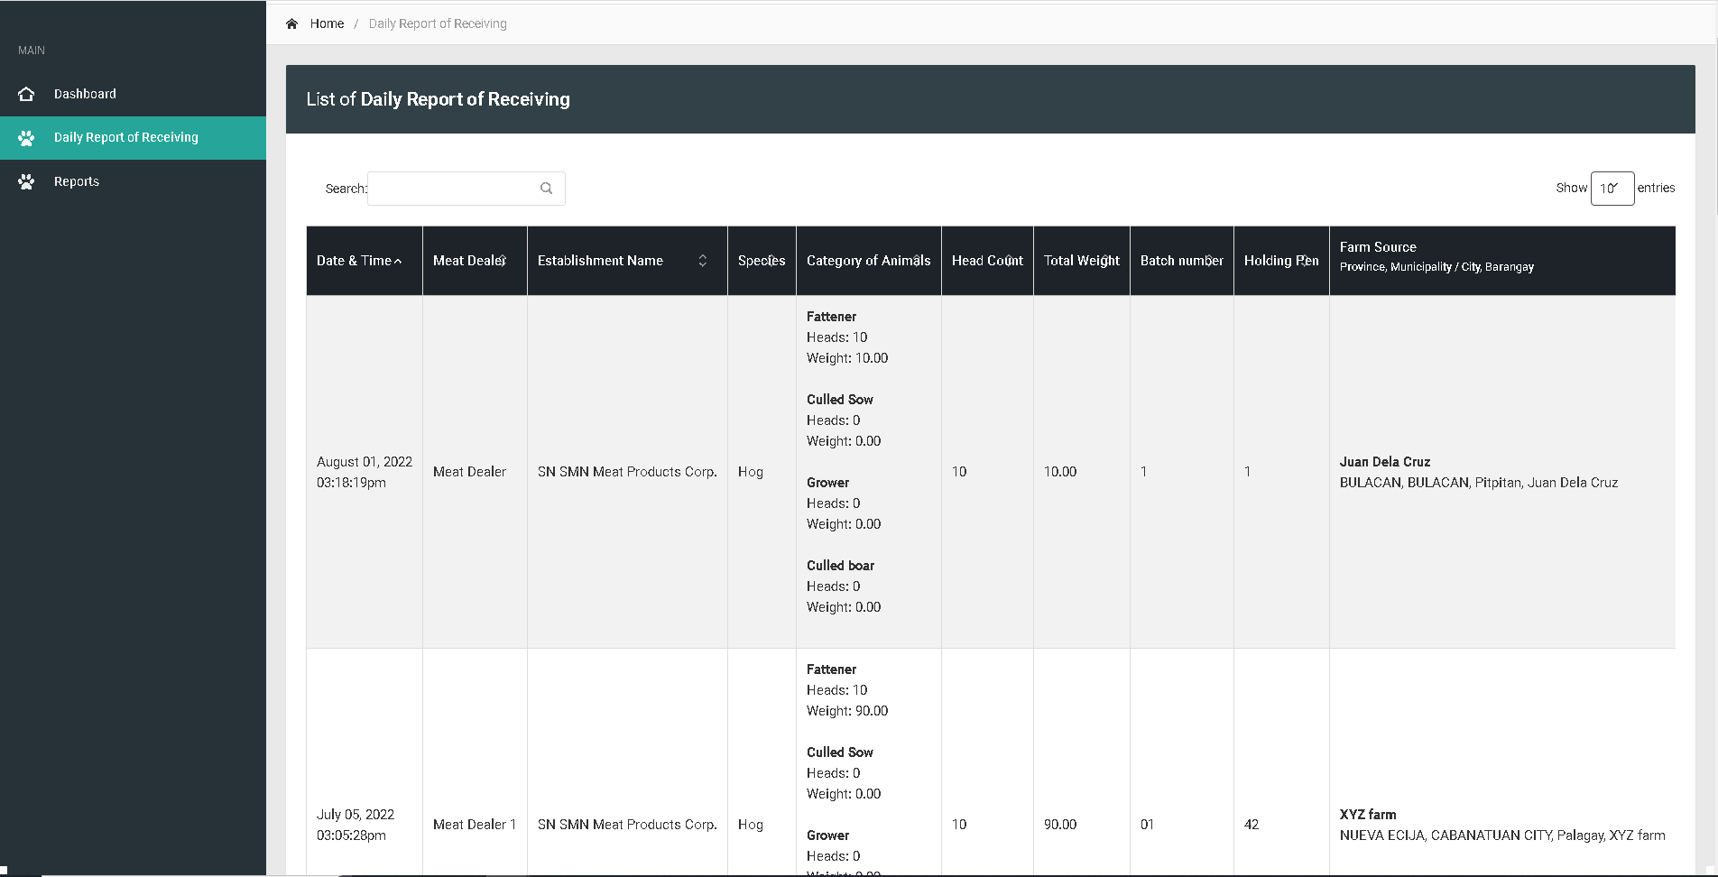

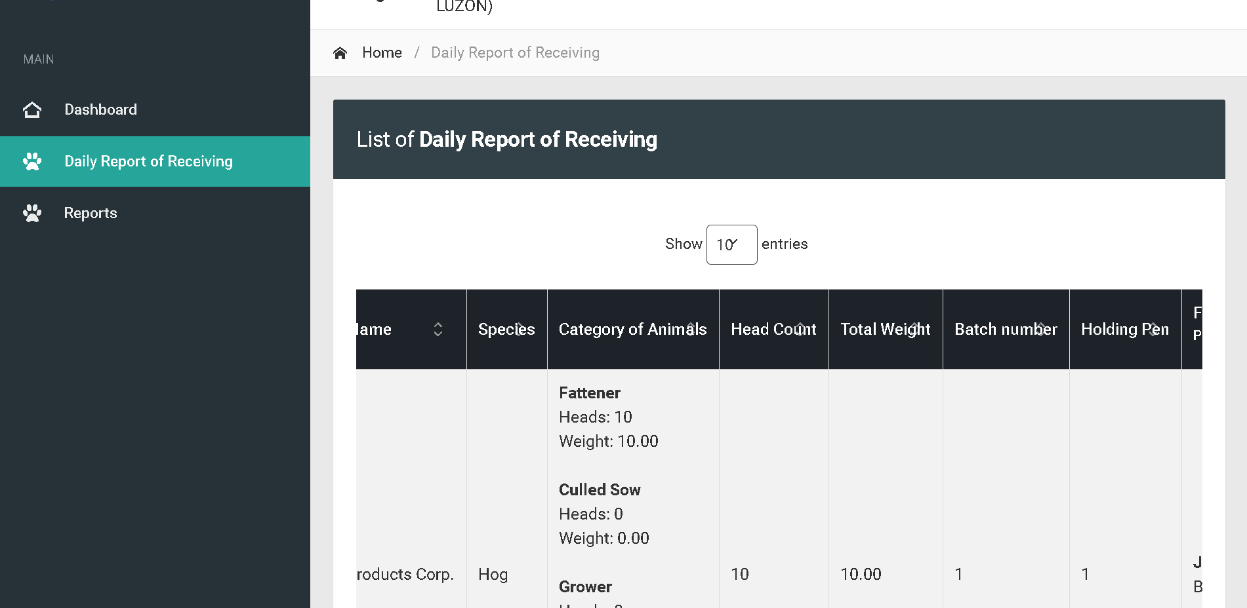

Change sidebar title to Daily Receiving of Animals

Bactch and holding pen : Text align center

For the column of head count and total weight make it text right

Change title to Daily Receiving of Animals

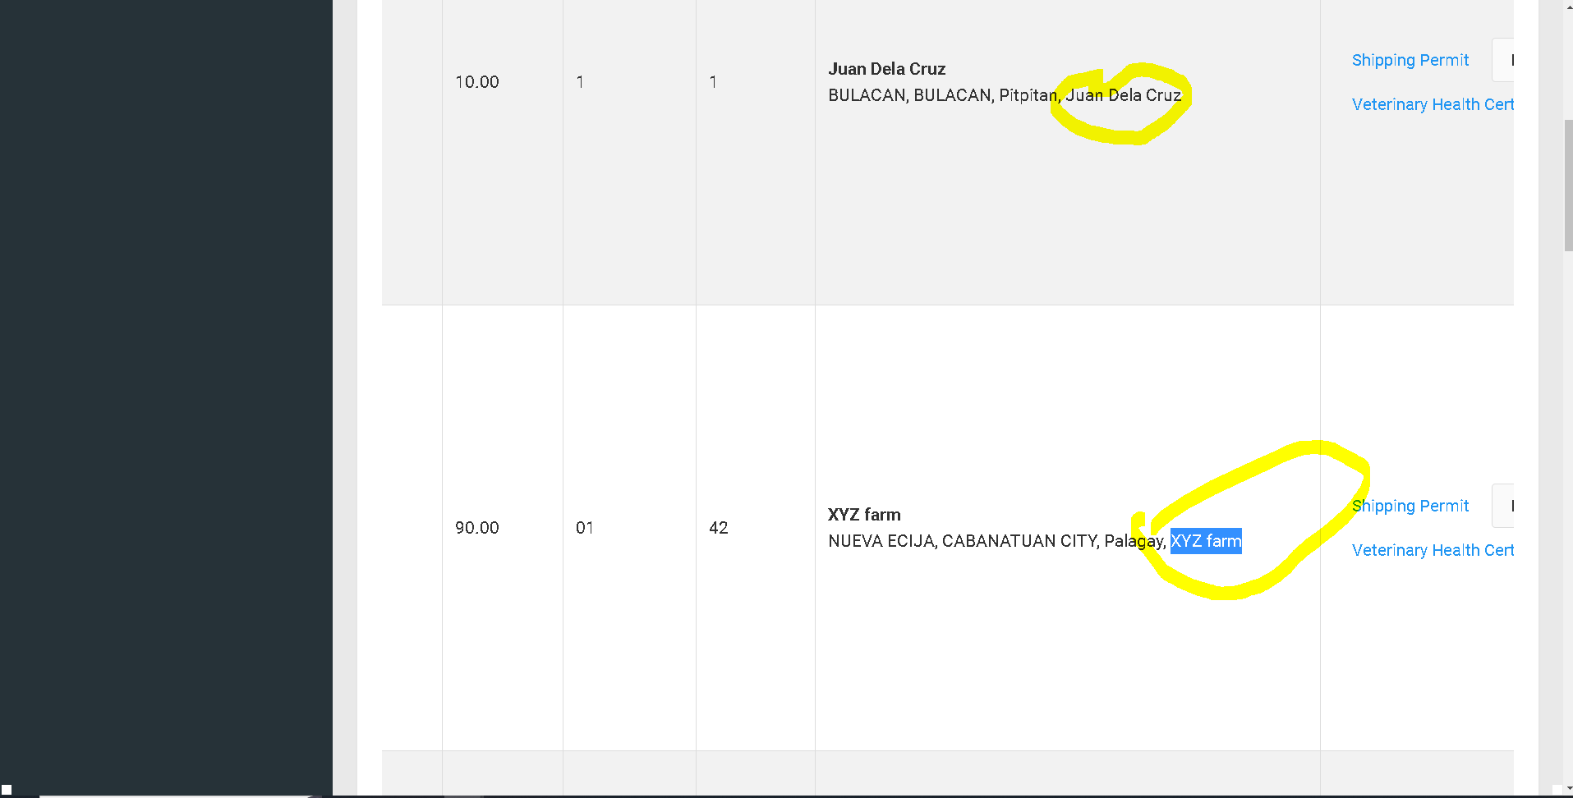

Remove on fetch data of line code

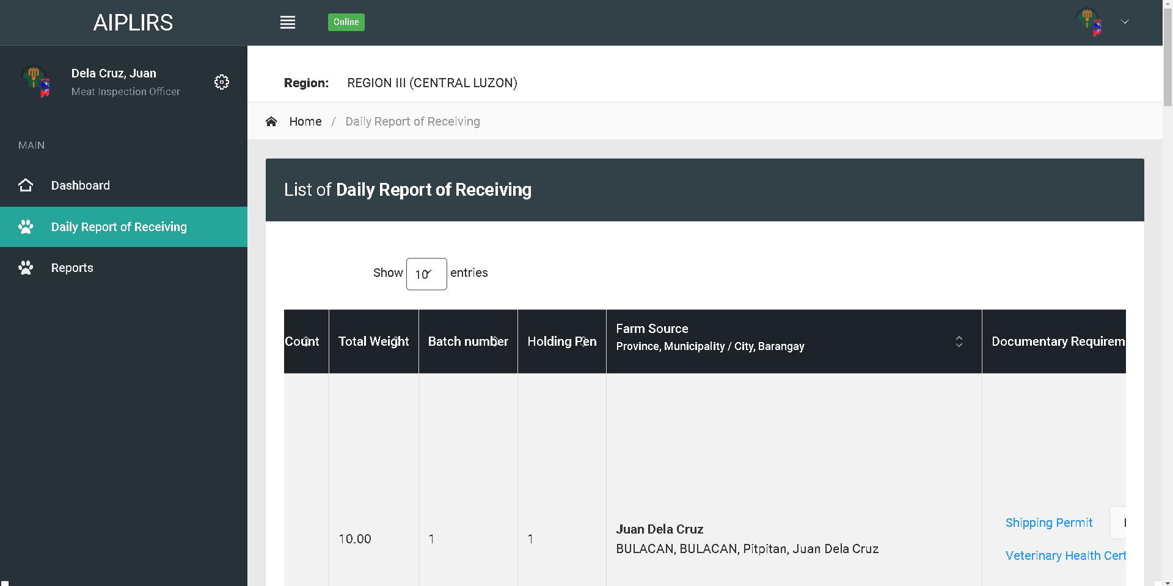

Change address format to “barangay, city, province”

Change table header

Farm Source and Address

Remove indicator

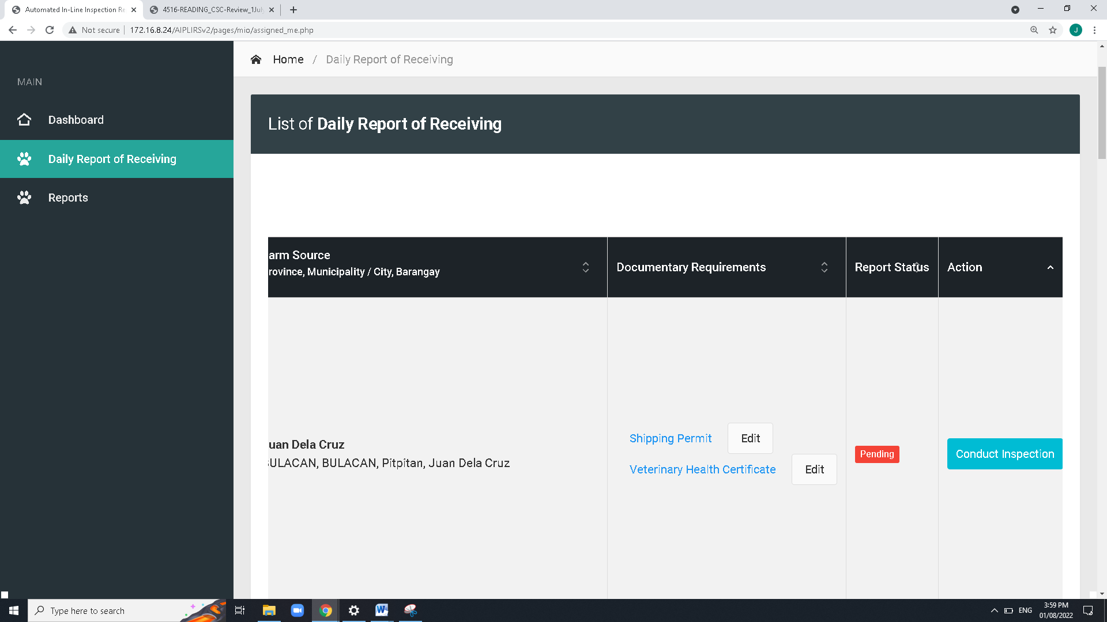

Add approve for the “Request to edit ” in the MIO button actions

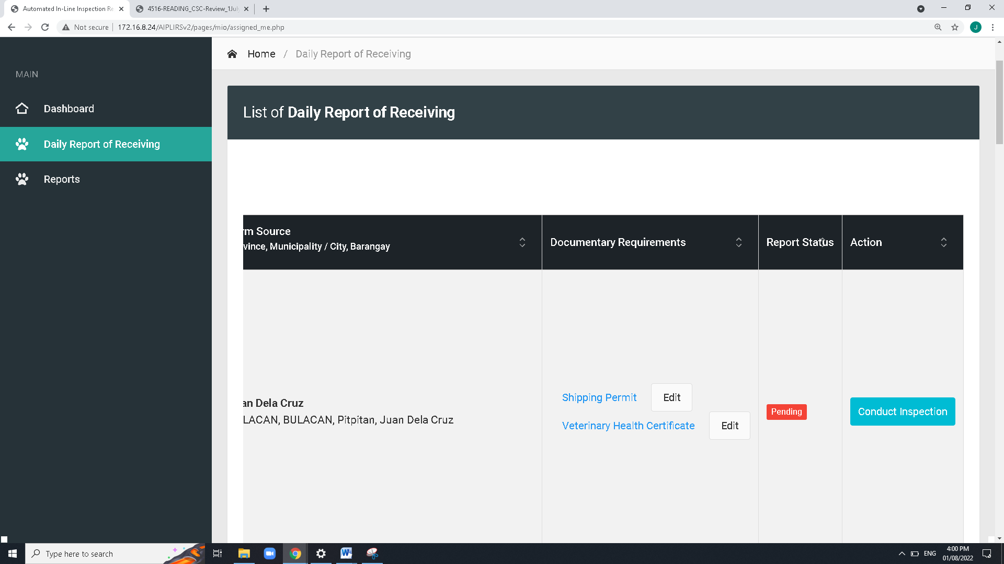

ME: Upload or Captured

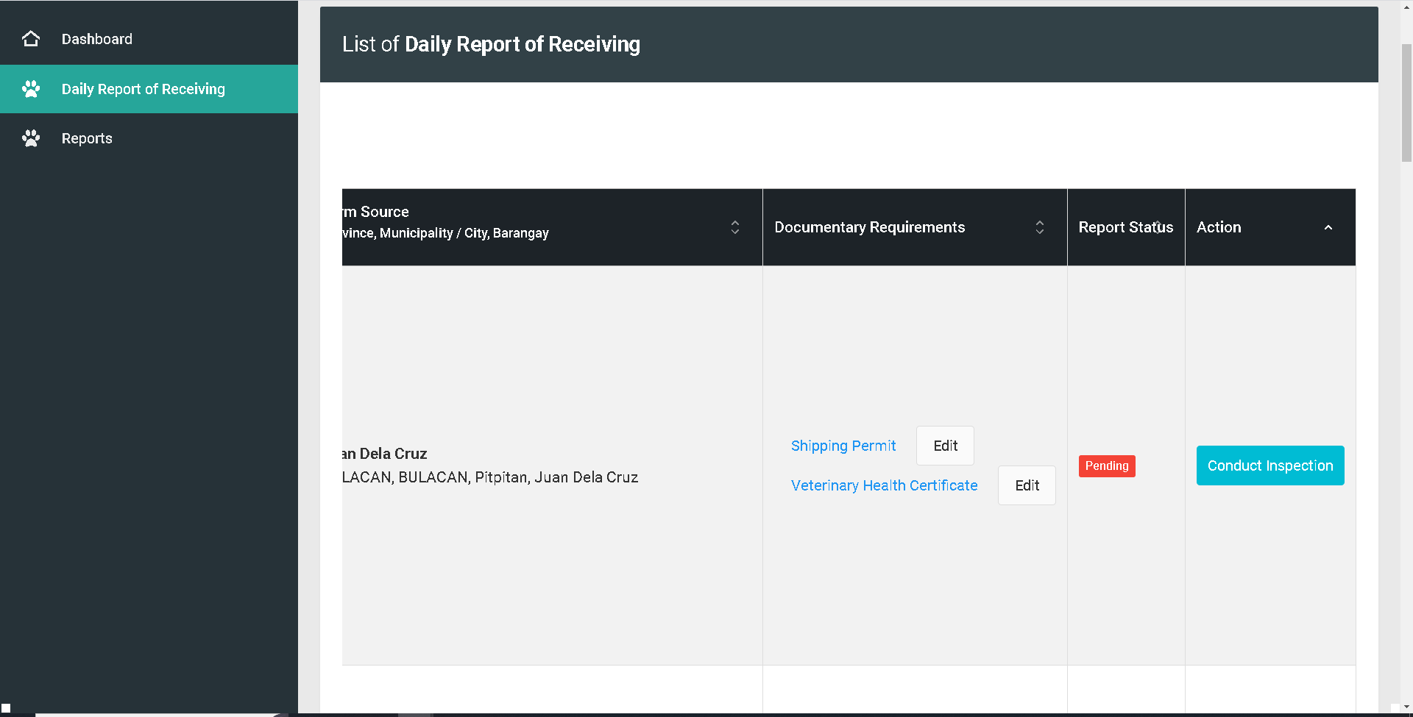

For the button of the of the shipping permit should change to Accept / Reject. Then system will notifiy the meat establishment for the edit of document

Change edit Accept / Reject

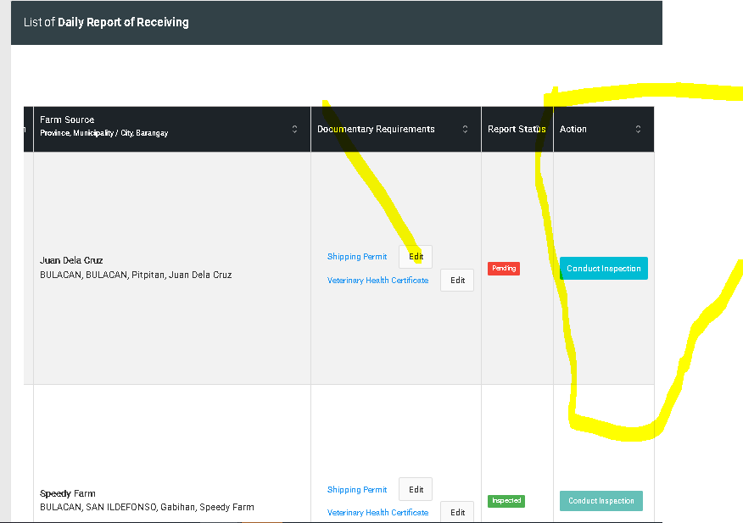

On action button change conduct inspection to proceed and button for reject

**Request to edit DRR** button:

for the reject button after clicking modal will appear and MIO will note the deficiencies or the correction of the data specially documentary req.

notification will appear on ME dashboard for the remarks,

**conduct inspection button** changes to proceed to inspection.

remove edit button on documentary requirements

report status:

add another page for the viewing of data and take actions, table data remove the drr status

Status: Pending

DASHBOARD CARDS : Status, Pending, Ongoing, completed

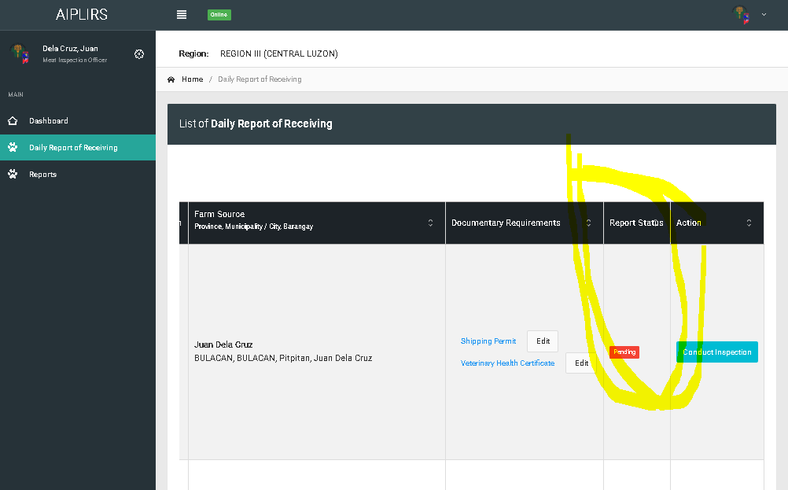

Remove the header highlighted

Details of DRR page: details

‘remarks must be visible both MIO and ME

Add a column for the “DRR status” and “Inspection report status”

Report status change to “DRR Status”

**DRR status**: **pending** (request to edit), **Completed**,

**Details of DRR page action**: **proceed to inspection**(DRR status will update to approved), **request to edit**

**Inspection report status**: **Pending**(upon checking Drr page), **On-going**(if DRR is approved color: orange), completed(Antemortem & postmortem conducted)

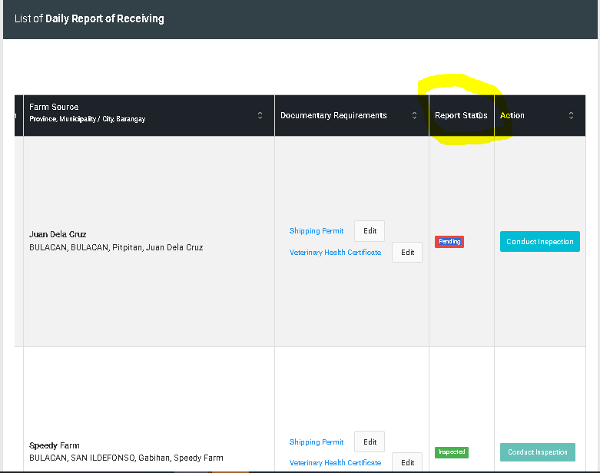

Change header for the DRR status

DRR status

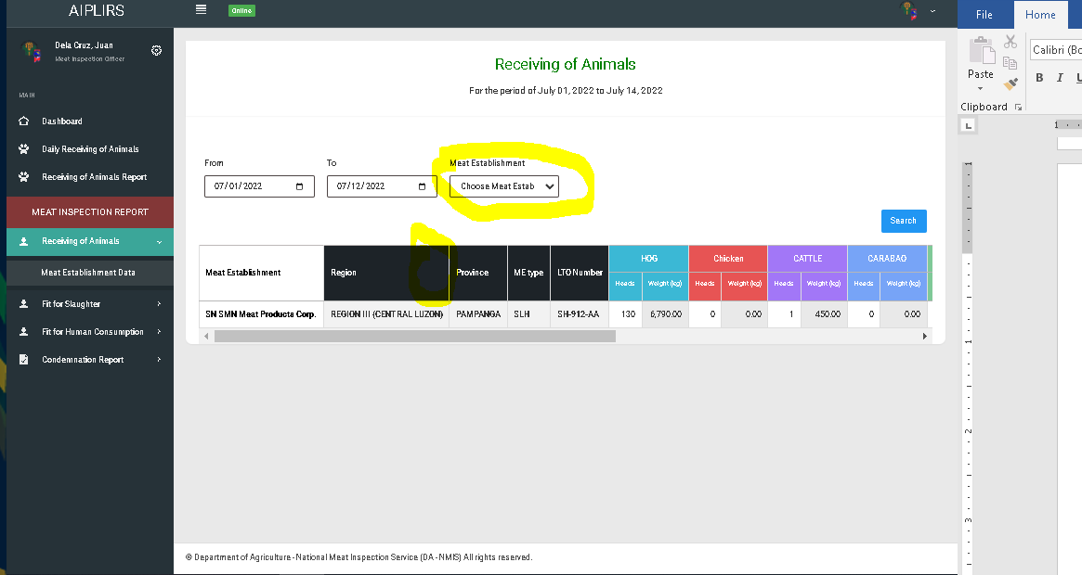

Add tick boxes on meat establishment option for filtering

Region sorting button

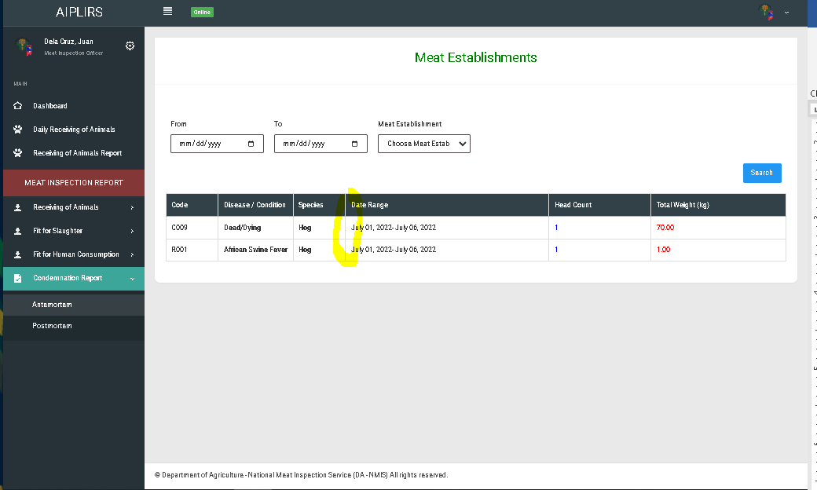

Add column for the judgement

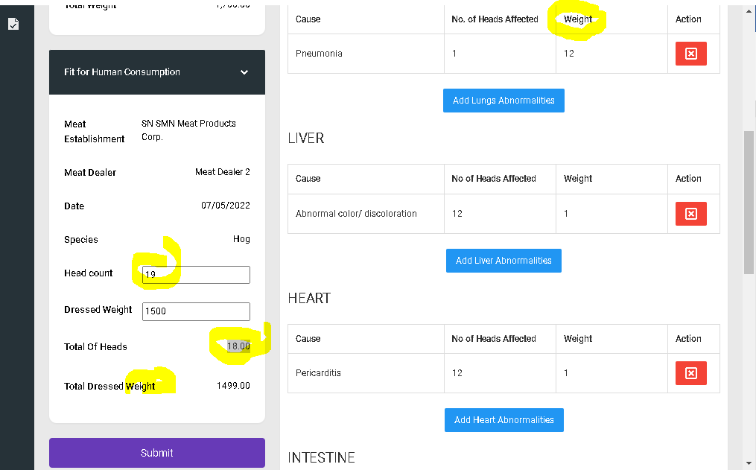

Change the title to” total head count”

Redo the codes that function the head count input based on fit for slaughter

Add kg on the weight label

same with the head count input output

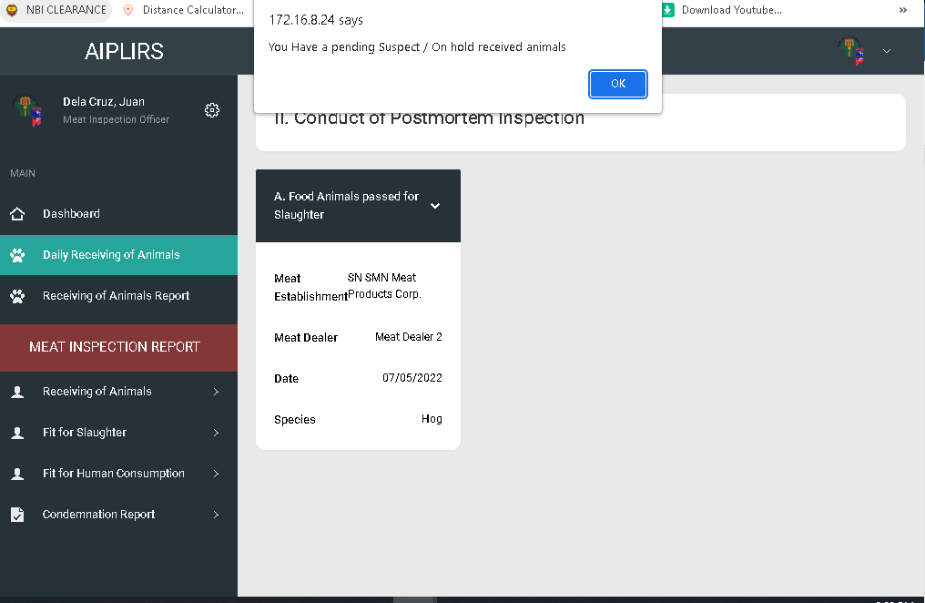

Sytem will be redirected to antemortem

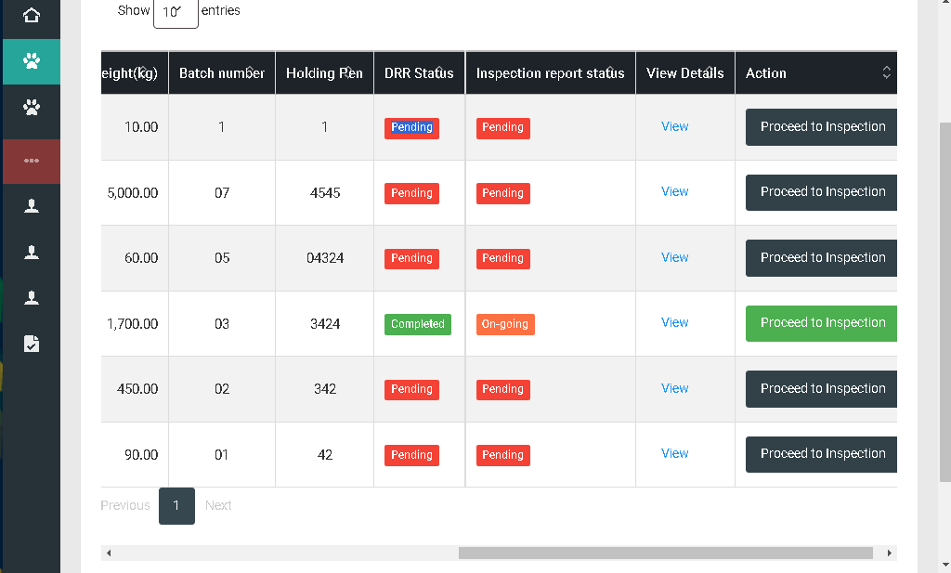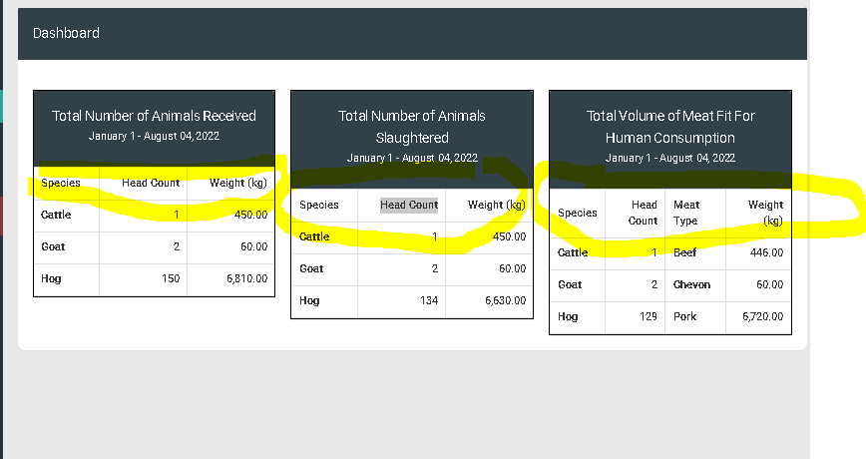

Remove action column meat dealer, total weight, batch numer, holding pen

Change positioning of after head count change header “drr details” button “td” view

Order of the table after drr details “DRR STATUS”, “INSPECTION STATUS”

Malke center all header

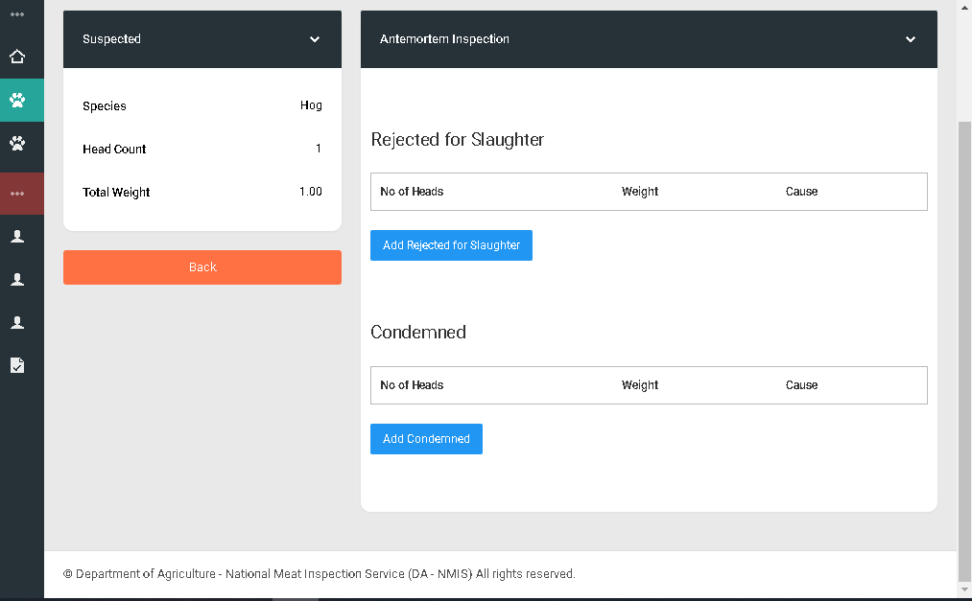

“Proceed to inspection button green” redirect to post-mortem inspection

Suggestion:” confirmatory result

“Passed for slaughter” add a row

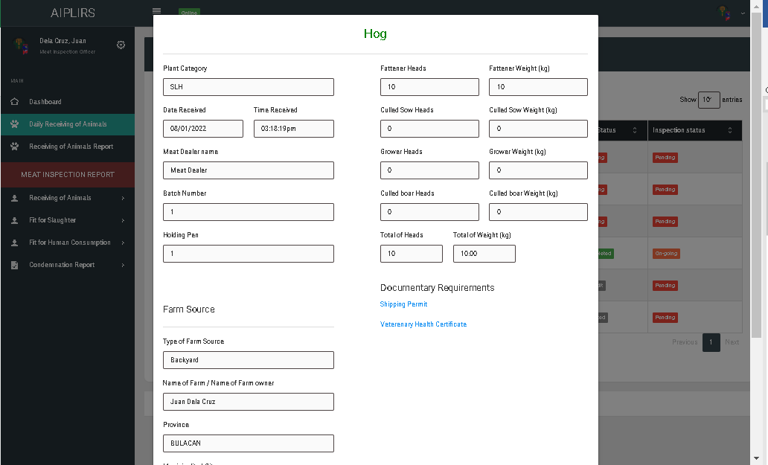

Plant category change to “type”

Isang linya para sa farm source

Para sa batcha t holding pen pagisahon sa isang row

Kapag zero ang value ihide ang datapalitan ang total head count remove of on total weight

Gawa ng modal para viewing of shipping permit

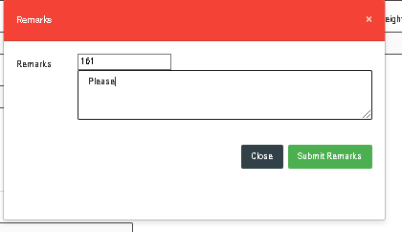

ID Unhidden

Remove remarks on label textarea

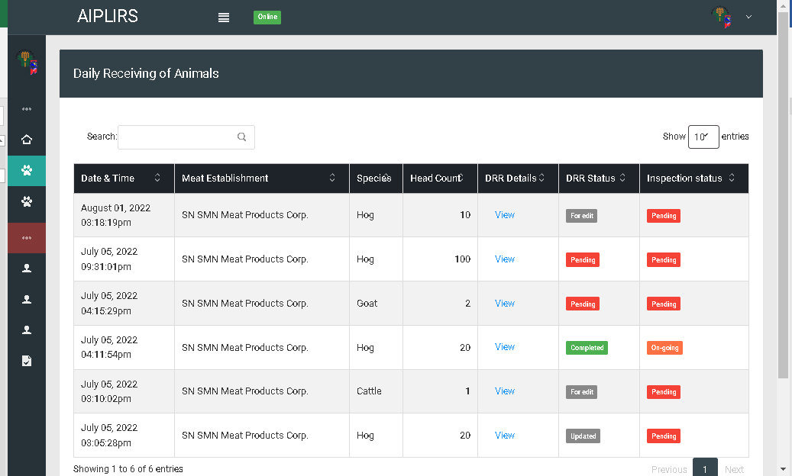

For edit change to for editing

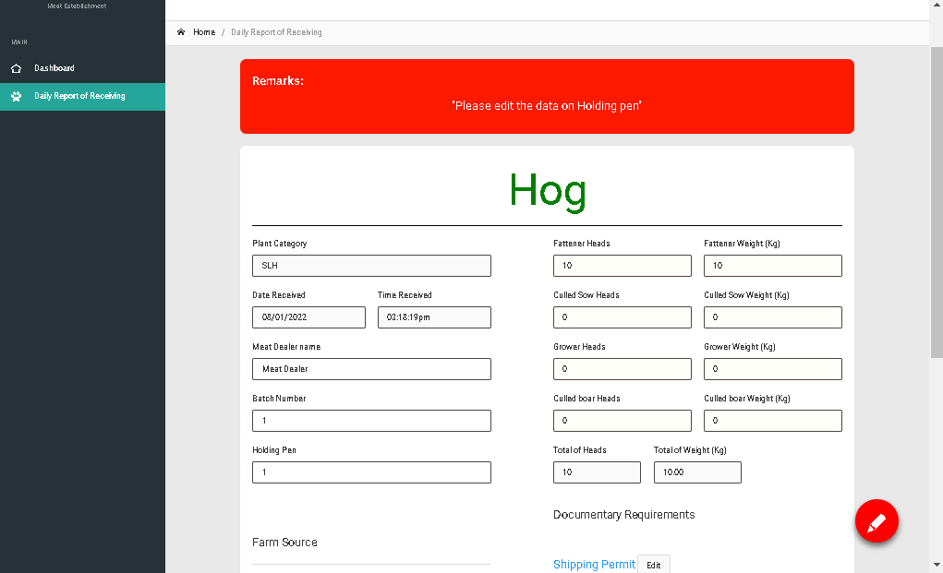

Remove species title

For editing : hexacode: 007de9

Updated : hexacode : 0ddddd

On going: hexacode: eba300

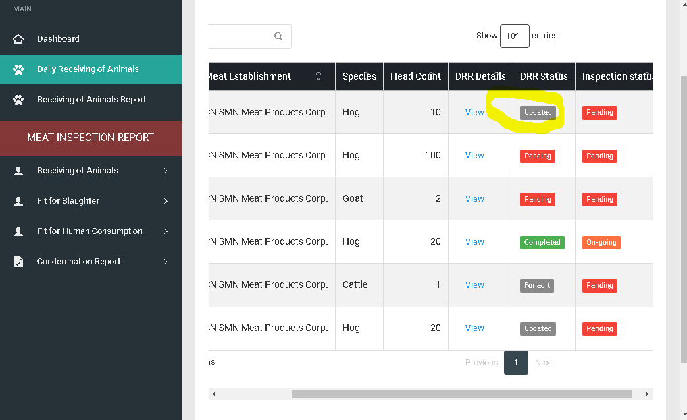

Same with “for editing “ button with modal remark details

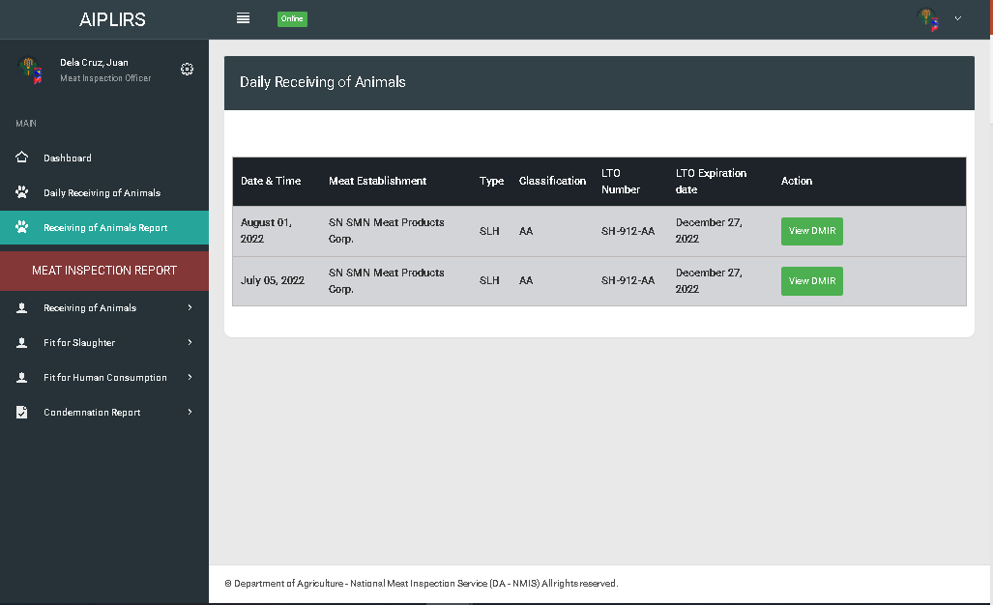

All table header is on centered

Receiveing, pass for slauighte, fhc: total head count

Weight to Weight (kg)

**No. of Heads Affected postmortem inspection**

Change to received animals

Header title remove

TH design for change

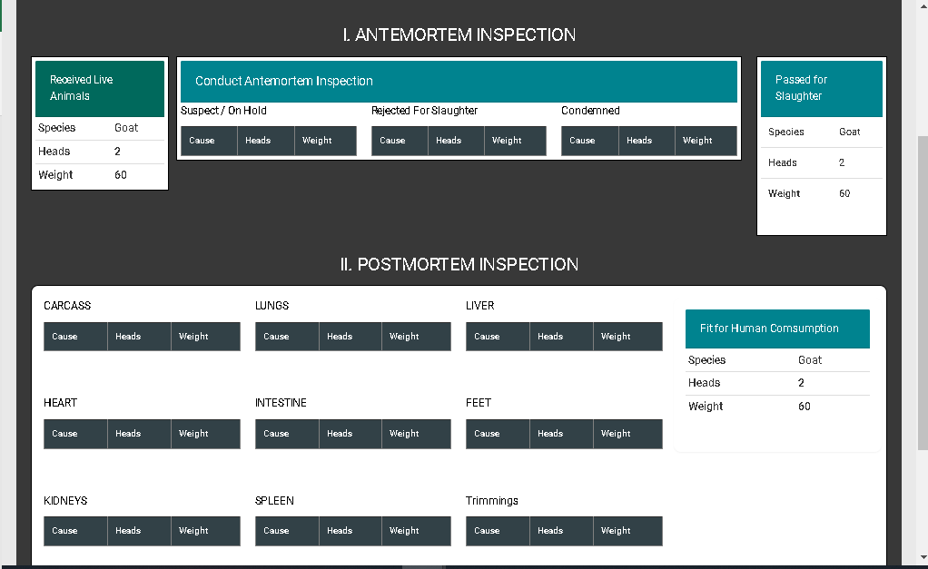

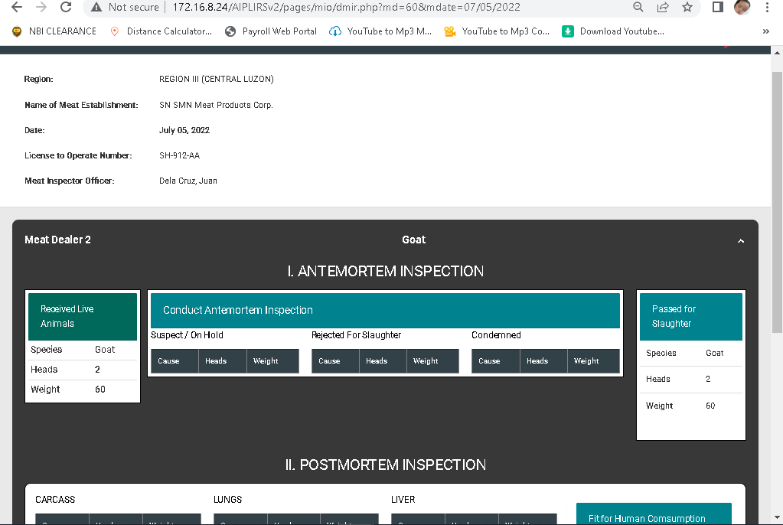

Date:

Region:

Meat Inspection Officer:

Segregate into 2 column

Meat establishment name

Lto number:

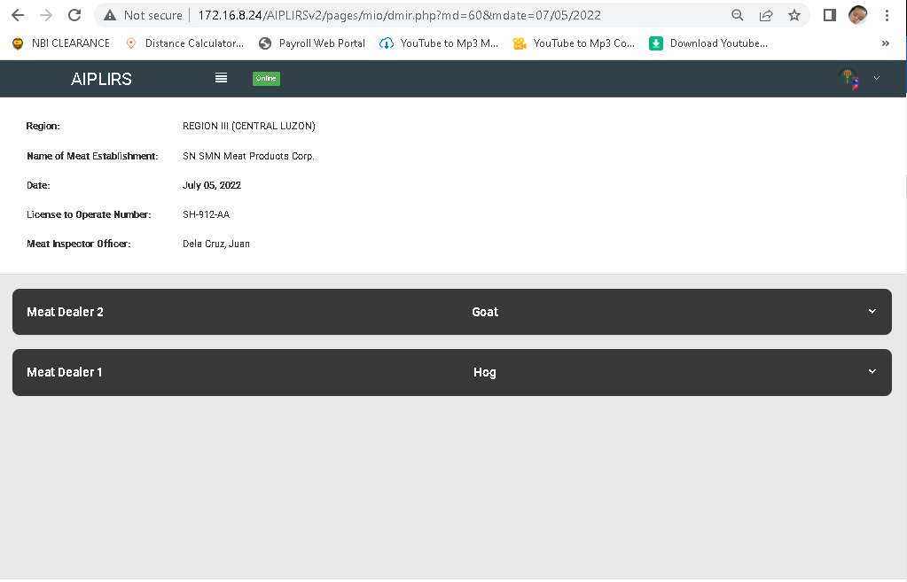

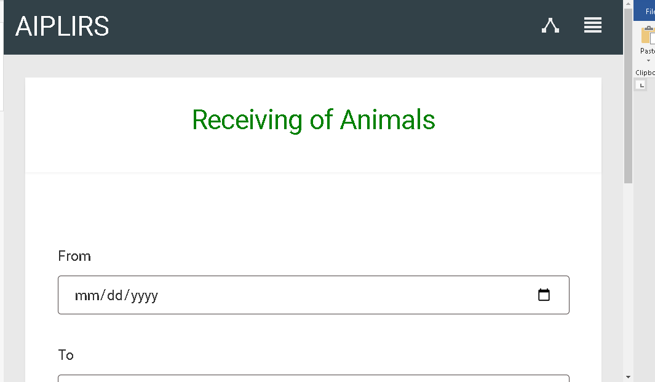

Make the font weight Into bold on all pages

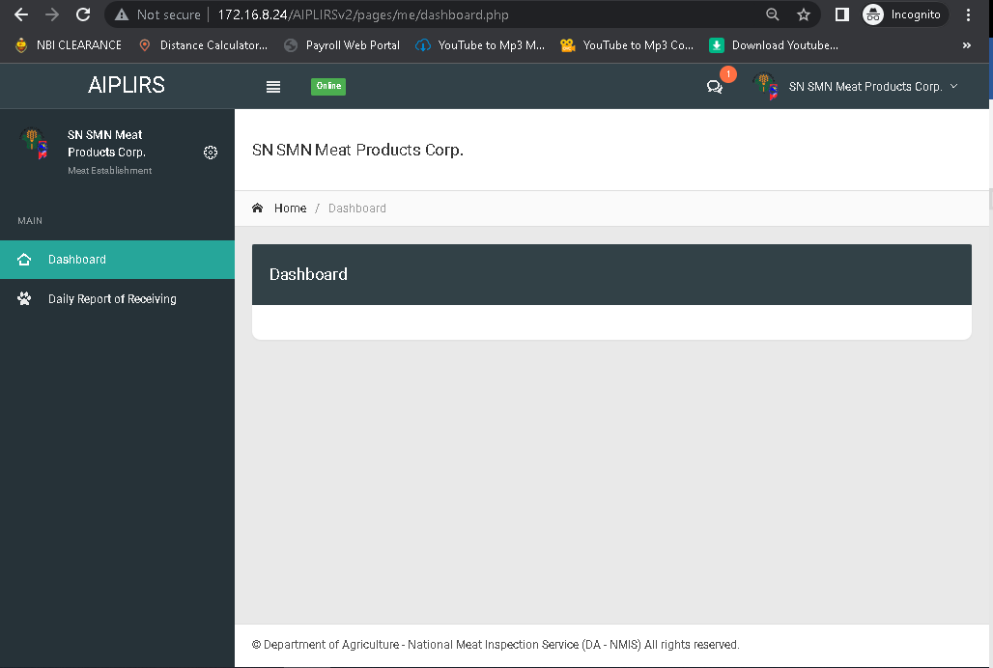

Summary for the receiving,